

**UNIVERSITI TEKNOLOGI MARA KAMPUS SEGAMAT**

**REPORT PERSONAL WEBSITE**

**TITLE: ART PORTFOLIO**

**CSC318: WEB APPLICATION SYSTEM**

**LECTURER:** MISS HUZAIFAH BINTI MOHD SALAMON

**GROUP:** JCS1105G

|  |
| --- |
| **PREPARED BY:** |
| **ANIZ ATHIRAH BINTI ANUAR (2017241128)** |

**SUBMISSION DATE: 17/10/2019**

**CONTENTS**

|  |  |  |
| --- | --- | --- |
| **NO.** |  | **PAGE** |
|  | **COVER PAGE** | **i** |
|  | **ASSESSMENT’S RUBRIC** | **ii** |
| **1.** | **INTRODUCTION** | **1** |
| **2.** | **PRINT SCREEN OF THE WEBPAGE** | **2-6** |
| **3.** | **REFERENCES** | **7** |
| **4.** | **SOFTCOPY** |  |

**INTRODUCTION**

“ARTHEERAH” is a website created to showcase the world of art to others. In this modern day where art is appreciated by everyone in this world. The main theme of ARTHEERAH’s website is a mixed of traditional and digital arts.

Starting from the main or HOME page, the website displays general greeting to the visitors, newest featured video, SHOP link and sign up form for future updates. Next, we have ABOUT ME page talks about an anecdote on how the creator of ARTHEERAH’s history. After that, we have PORTFOLIO page, a page where some arts are being displayed as similar as gallery. Besides, ARTHEERAH also opens an upcoming shop soon in the SHOP page. Finally, the last page included in ARTHEERAH’s website is the INQUIRY page, visitors may sign up his/her personal details and rate the ARTHEERAH’s site.

**PRINT SCREEN OF THE WEBPAGE**

1. HOME PAGE

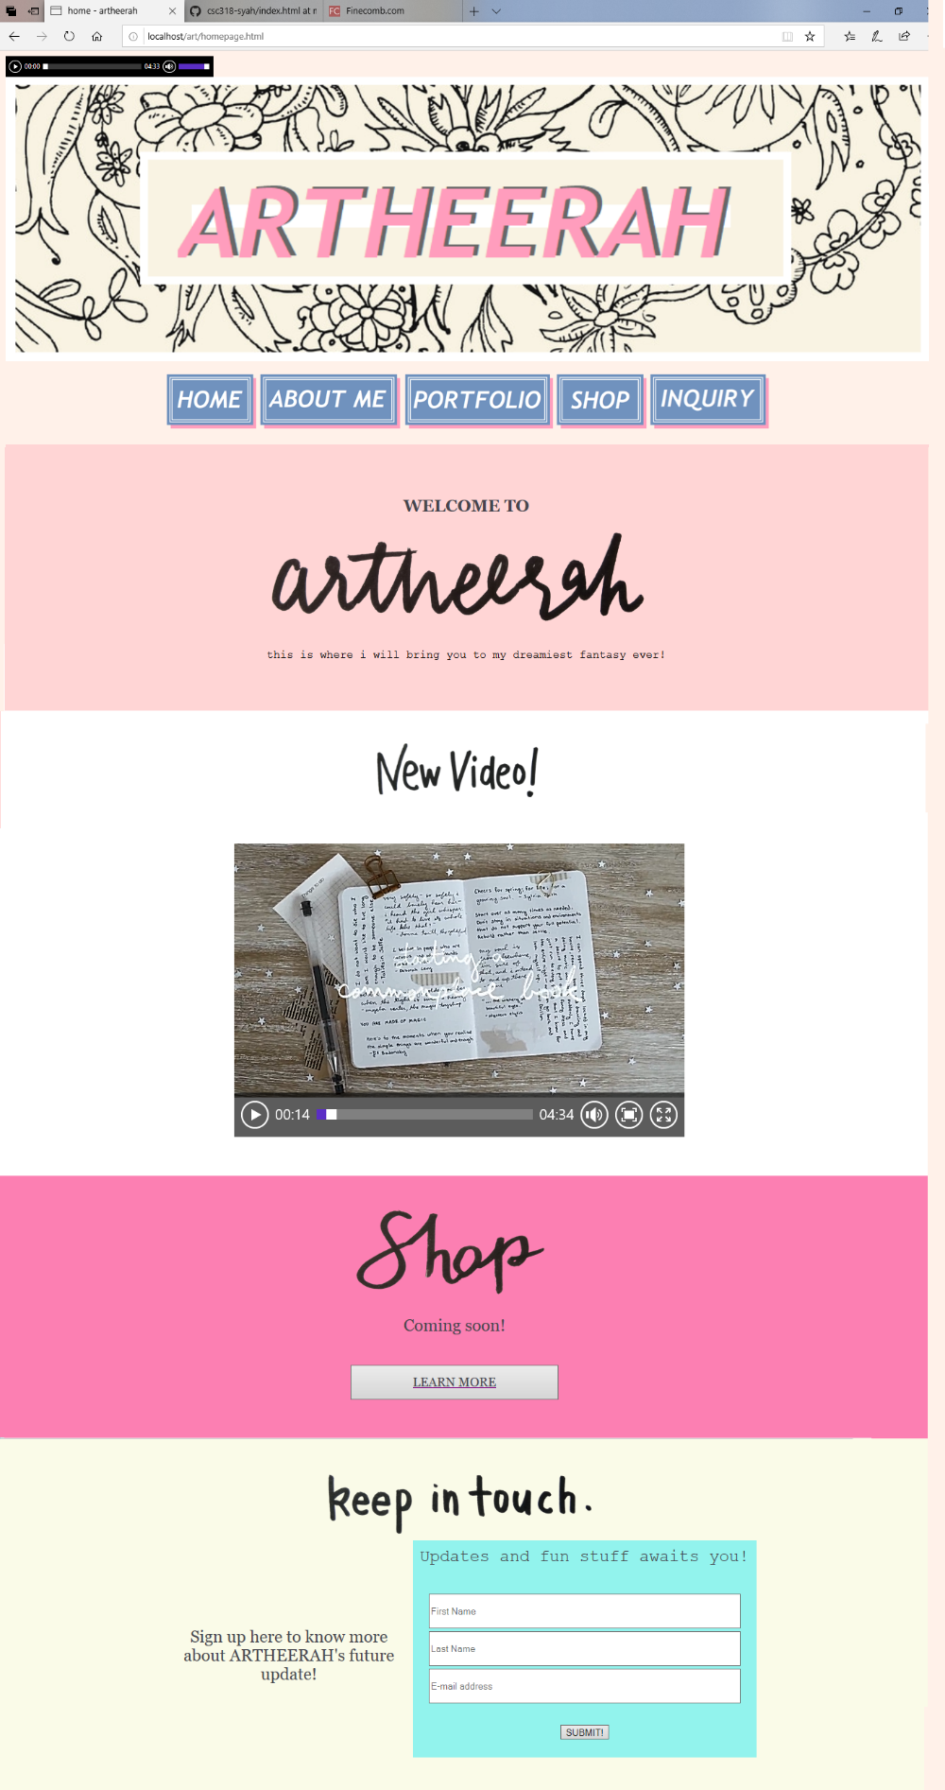

1. ABOUT ME PAGE

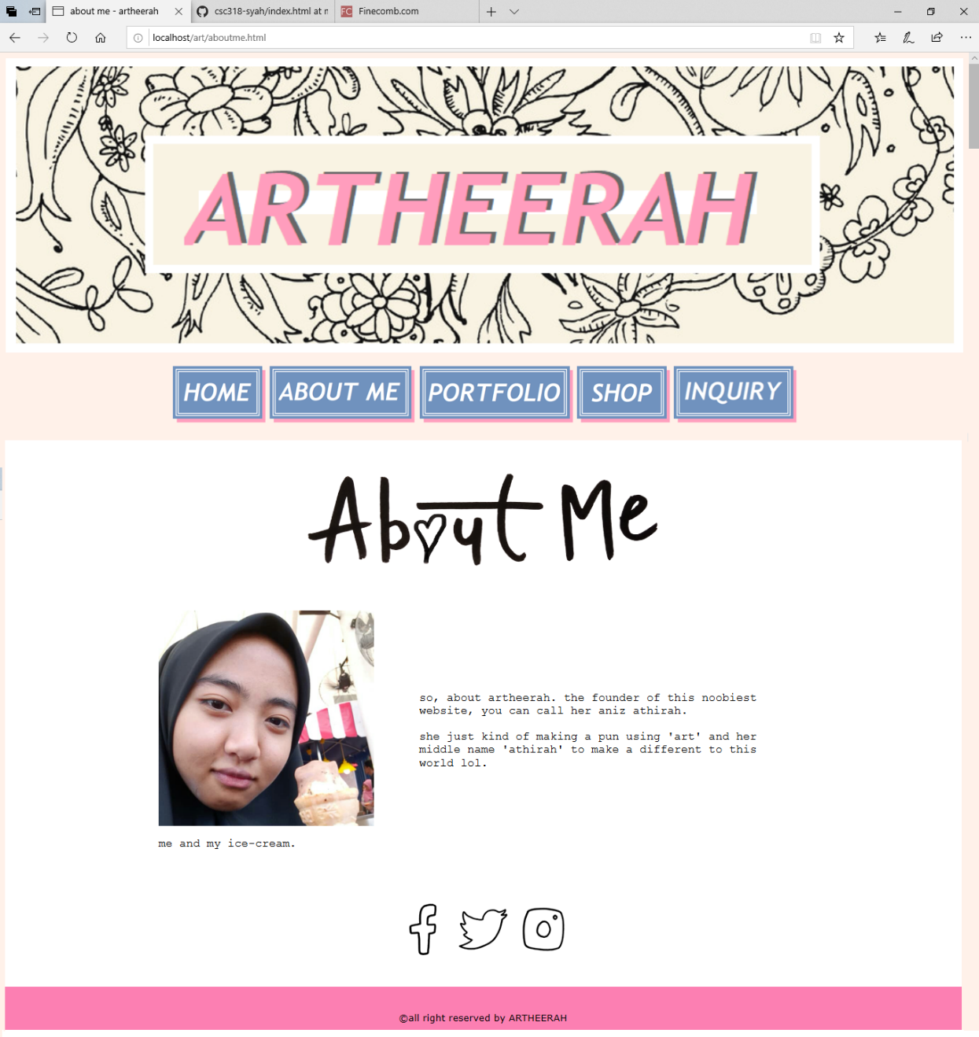

1. PORTFOLIO PAGE

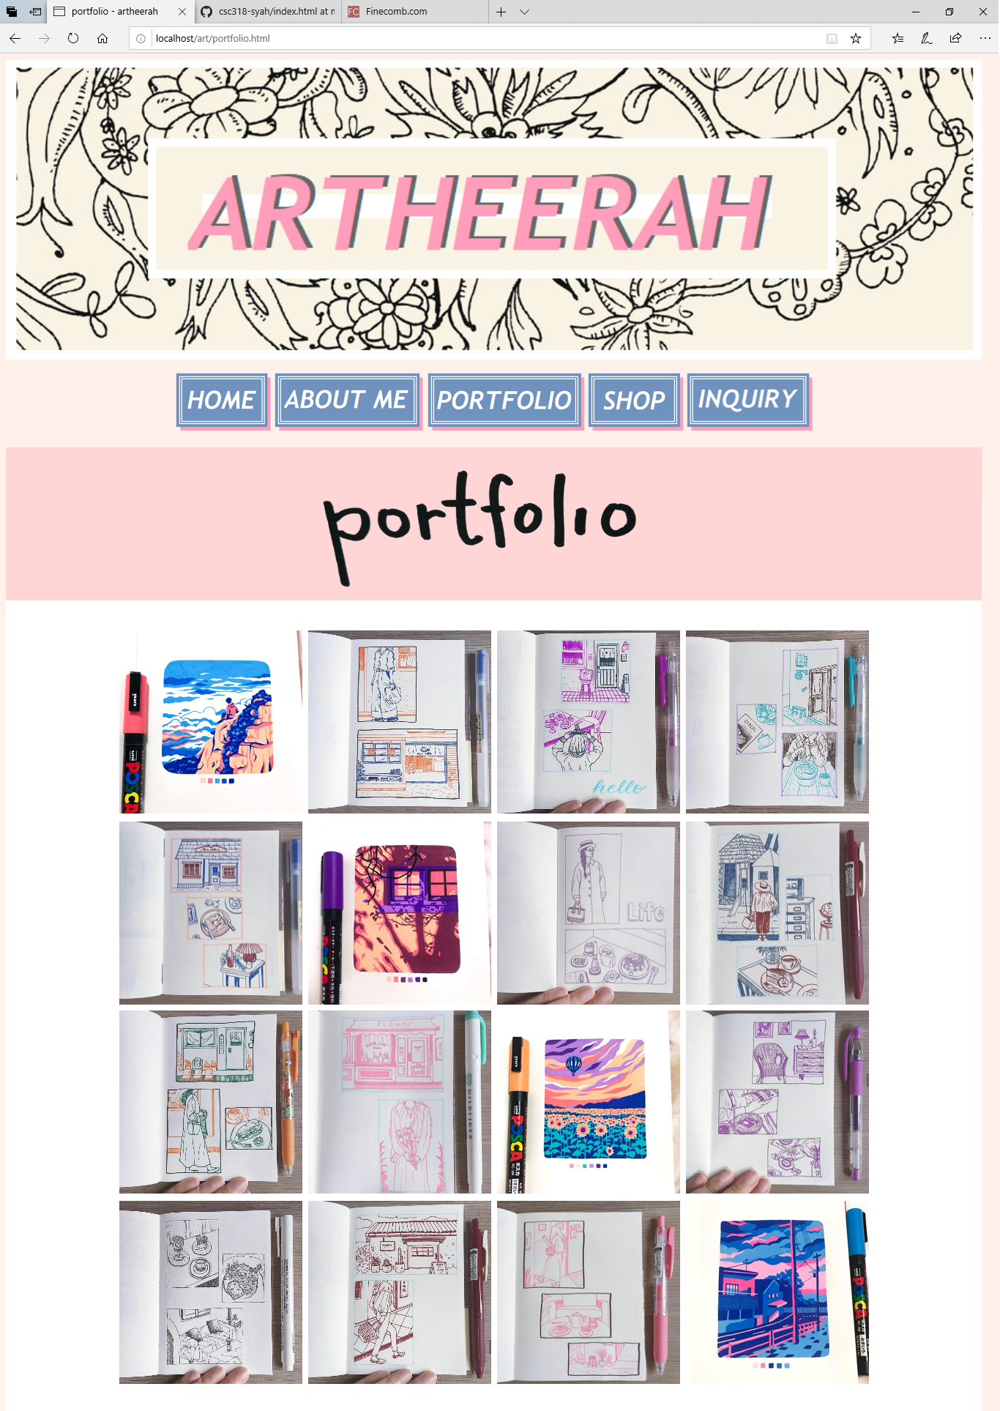

1. SHOP PAGE

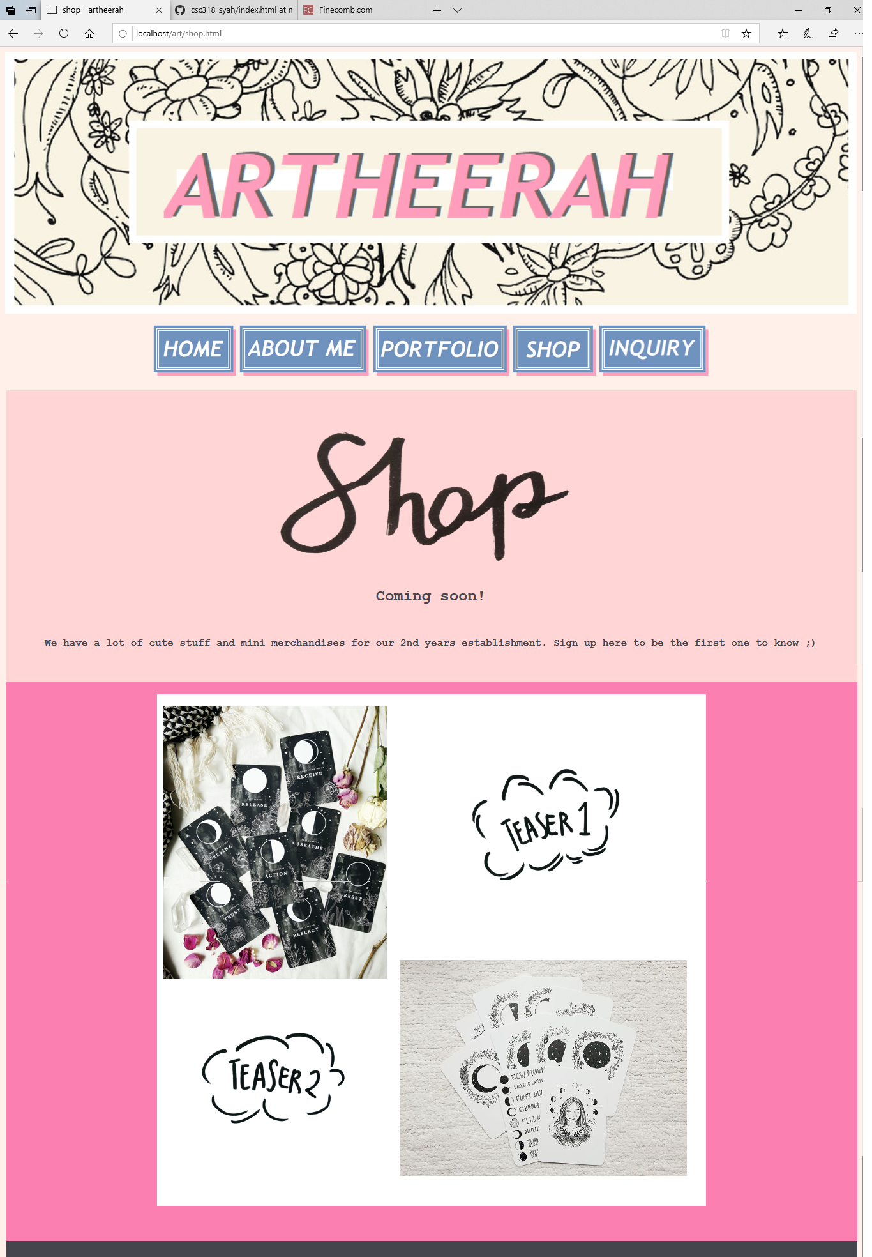

1. INQUIRY PAGE

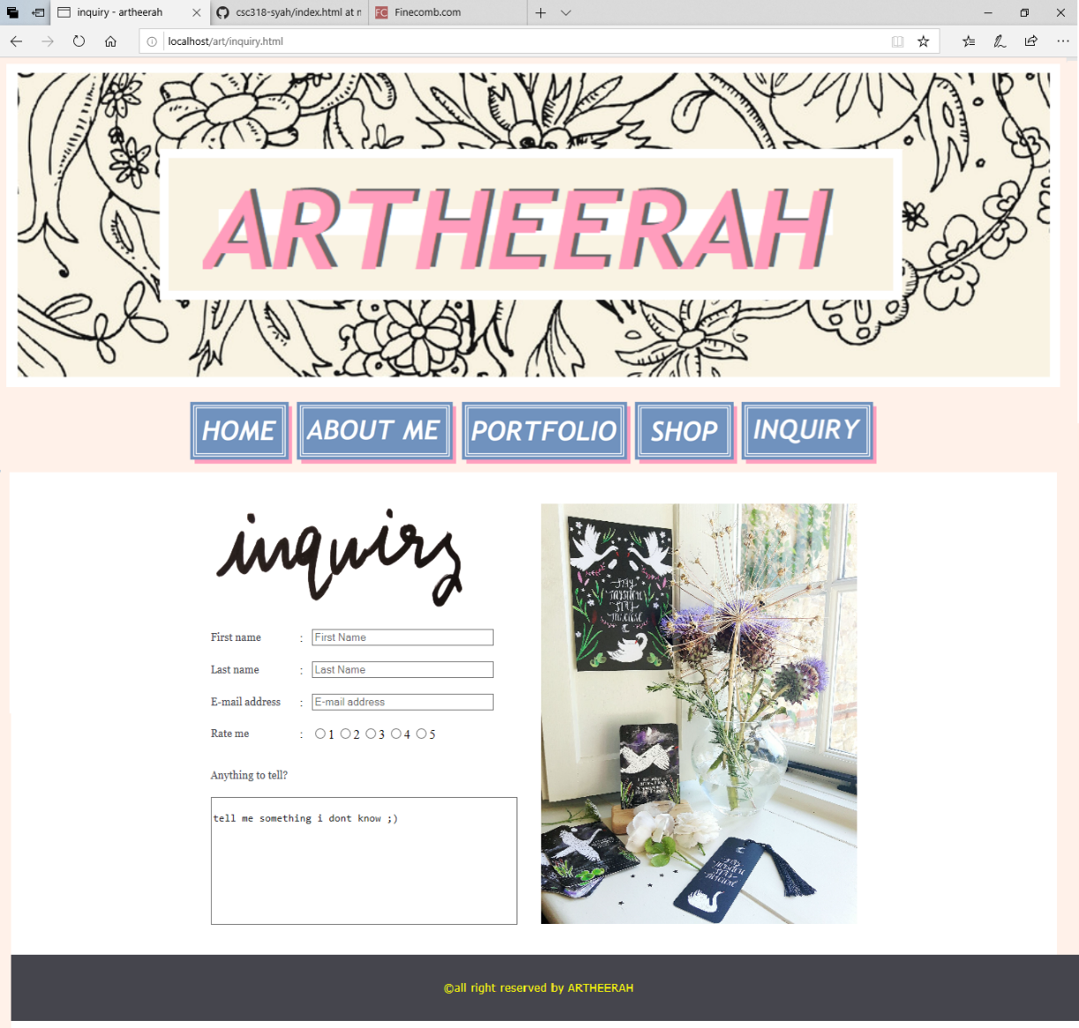

**REFERENCES**

1. About. (n.d.). Retrieved from <https://www.amandarachlee.com/about>.
2. Mega site of Bible Information. (n.d.). Retrieved from <http://www.w3school.com/>.